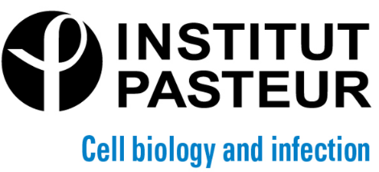

Seminar
"Collective effects in epithelial cell elimination"

presented by Romain LEVAYER
(Department of Developmental and Stem Cell Biology,
Institut Pasteur, Paris)

Monday, March 6th , 2023 at 12 pm

Auditorium François Jacob

Invited by Timothy WAI
(timothy.wai@pasteur.fr)

Abstract:
While the signals regulating apoptosis during development are rather well known, what sets the precise spatio-temporal distribution of cell death and the adjustment of cell elimination to local perturbations is not well understood. Similarly, how cells eventually engage in apoptosis and how the removal of cells from epithelial layer is orchestrated through cell extrusion remained poorly understood, especially in vivo. In this seminar, I will illustrate the multi-layered regulation of cell death through three examples, the first one describing the impact of mechanical stress on cell elimination, the second one on local feedbacks that can fine tune the distribution of cell elimination in space and time, and the last one focusing on the engagement in apoptosis and the coordination of cell extrusion by caspases. Altogether, I will propose a roadmap to build a more predictive understanding of cell death in vivo that can directly impact tissue homeostasis, morphogenesis, growth and clonal selection.

