____________________________________
Executive Scientific Division/SPAIS

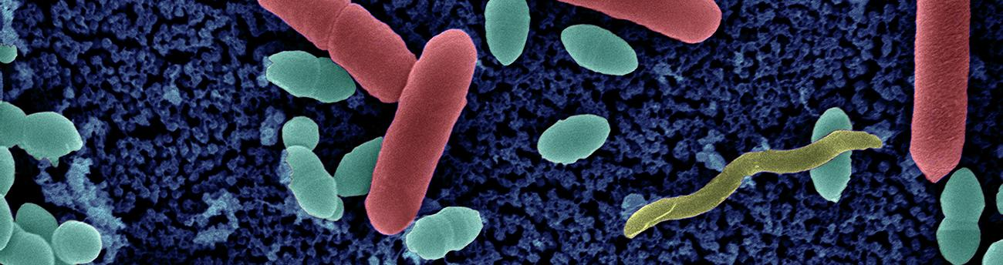
AMR axis
Call for proposals - Master Students

- Application Form 2023 -

Completed application form should be sent before the Wednesday 16th, November 2022 (6pm) to spais.coordination@pasteur.fr, specifying the subject as “AMR axis Call 2023- Master Students “. We will acknowledge the receipt of all the applications.

Application to be submitted in a single .pdf file and named as follow: Applicant’s SURNAME Name_ Lab Head’s SURNAME.pdf (example: SMITH John_Lab CARTER)

APPLICANT INFORMATION

APPLICANT
- FAMILY name & First name:
- Age
- Nationality
- E-mail address
- Current affiliation (University, Engineer, Medical School etc)
- Title of your Master (when applicable)
INSTITUT PASTEUR HOST RESEARCH ENTITIES
First Host Entity
- Name of the head
- Name of the supervisor
- Project title
- Preferred start date of the scholarship
Second Host Entity (when applicable)
- Name of the head
- Name of the supervisor

SUMMARY OF THE PROJECT PROPOSAL (0.5 page max, Arial 12-point)
Provide a brief and clear description of the background and rational of the research proposal, the hypothesis, main objectives, the most significant experimental approaches, and the relevance to the scientific field.

- Project title:
- Keywords (up to five):
- Summary of the project (20 lines, 1.5-spaced, Arial 12-point):

DETAILED DESCRIPTION OF THE SCIENTIFIC PROJECT (1 page max, Arial 12-point)
Including a detailed planning of experiments and techniques to be used, and budget description. List the main publications of the host research entity(ies) related to the scientific project.

Context:

Objectives:

Work Plan:

Outcome and future directions:

SIGNIFICANCE /ARTICULATION OF THE PROPOSAL WITH THE AMR RESEARCH ACTIVITIES (10 lines max)
Highlight how the proposal fits within the scope of the AMR research areas.

MOTIVATION OF THE MASTER STUDENT (1 page max.)
Explain why you would like to work on this research proposal.

CV OF THE MASTER STUDENT Annex 1

