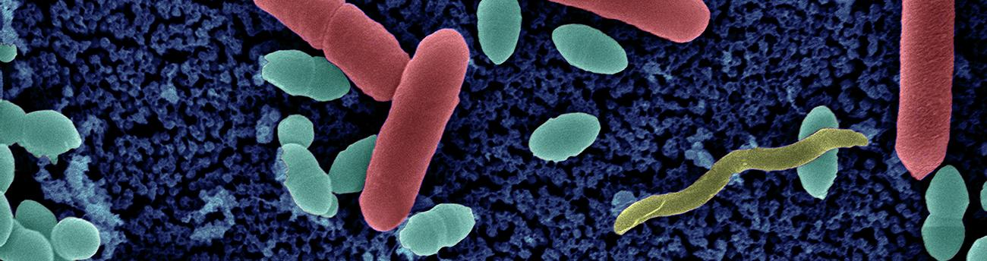
Antimicrobial Resistance

M2 Master’s students

Application Form

- Completed application form should be sent before the Friday 11th, December 2020 to spais.coordination@pasteur.fr, specifying the subject as “AMR Call 2020- Master’s Students “

- Application to be submitted in a single .pdf file and named as follow: Applicant’s SURNAME Name_ Lab Head’s SURNAME.pdf (example: SMITH John_Lab CARTER)

APPLICANT INFORMATION

APPLICANT
- FAMILY NAME, First name:
- Age
- Nationality
- E-mail address
- Current Affiliation (University, Engineer or Medical School)
- Title of your Master
INSTITUT PASTEUR HOST RESEARCH ENTITIES
First Host Entity
- Name of the head
- Name of the supervisor
- Project Title
- Preferred start date of the scholarship
Second Host Entity (when applicable)
- Name of the head
- Name of the supervisor

- DESCRIPTION OF THE PROPOSAL (1 p. max, Arial 12-point)

Context:

Objectives:

Work Plan:

- SIGNIFICANCE /ARTICULATION OF THE PROPOSAL WITH THE AMR RESEARCH ACTIVITIES (10 lines p. max)

- MOTIVATION OF THE MASTER’S STUDENT (10 lines max.)
Explain why you would like to work on this research proposal.

- CV OF THE MASTER’S STUDENT, Annex 1

