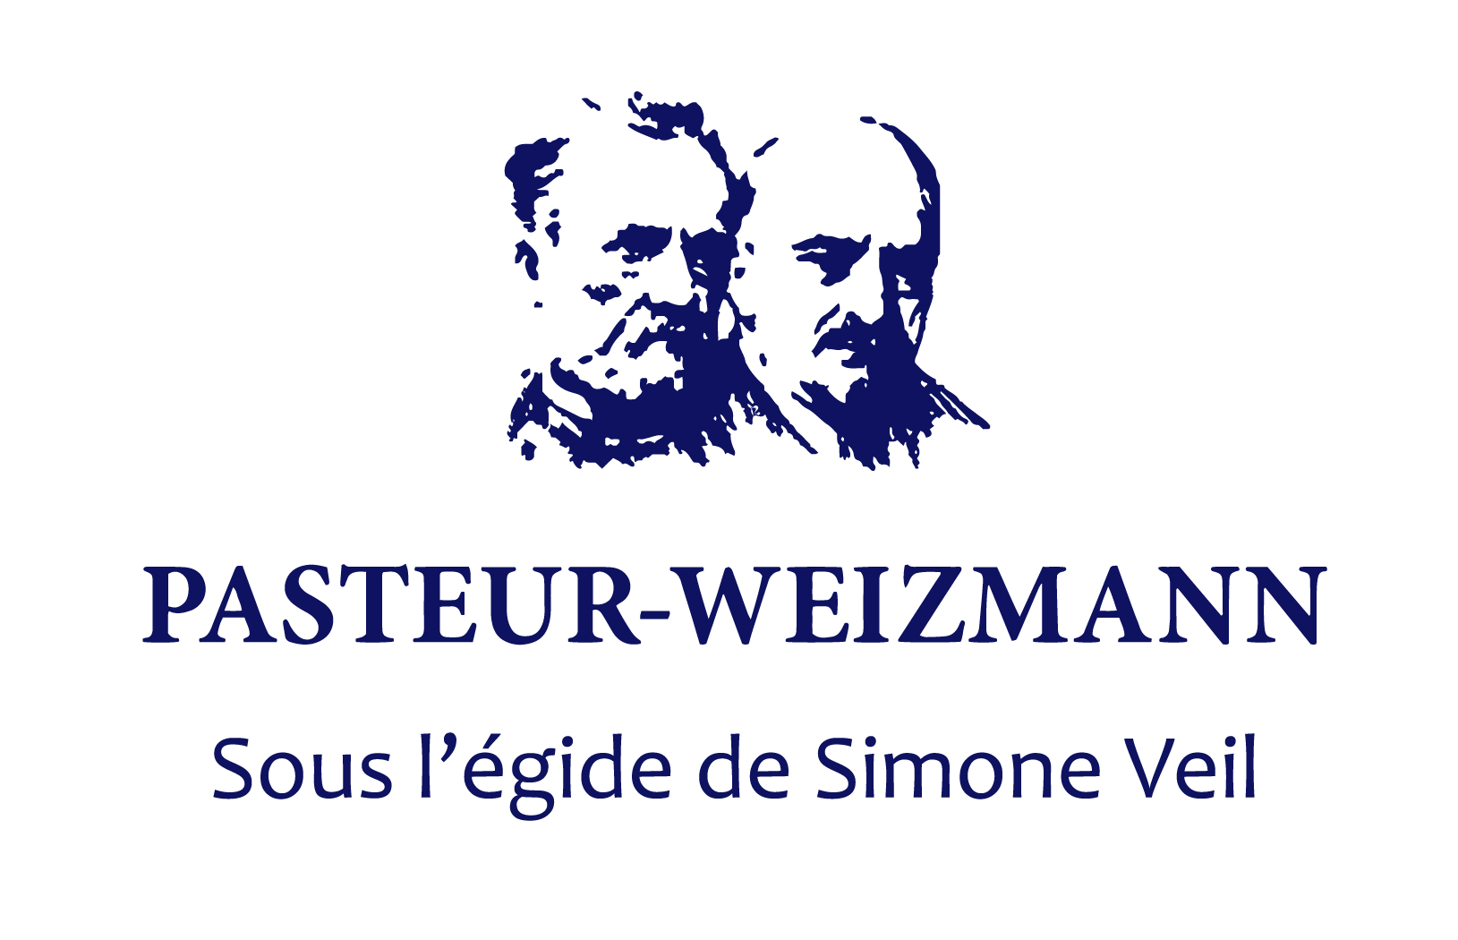
THE PASTEUR-WEIZMANN JOINT RESEARCH PROGRAM
COLLABORATIVE RESEARCH GRANTS
Funding starts on January 1st, 2023

Applications: Dead line: October 31st, 2022 (midnight, Israel time).

Introduction
The goal of these grants is to encourage and promote scientific collaboration between groups of the Institut Pasteur and the Weizmann Institute of Science. Research groups in the two Institutes that share common scientific interests may submit a joint grant application. This year, the P-W Research Program will support two grants:
- one grant targeted on microbial antibiotic resistance
- one non-targeted grant
Each project will be financed in the amount of 70,000 € per project per year (split equally between the two groups) and the duration of the funding will be 2 years. The major criteria for approval of a joint research grant will be the collaborative character of the project, its scientific excellence and the feasibility of the joint research.

Guidelines

1. Scientists that were awarded a grant during the last two calls (2020 and 2021) are not eligible.

2. Submission:
Applications will be prepared jointly by the two PIs in English on the application template available below. Please, submit the filled template only by email as a single PDF document (PW 2023 names of both PIs.pdf) to yael.karhash@weizmann.ac.il

3. Selection of projects:
Each Institute will appoint a local ad-hoc committee that will review the joint applications and rank them. The final decision on the allocation of support will be taken by the scientific committee of the Pasteur-Weizmann Council (see list below).

4. Reports and acknowledgements:
Extremely important for future efforts by P-W: A progress report should be prepared by the researchers and sent to the two coordinators by December 31th 2023. Final reports will be submitted no later than one month after the end of the supported period, December 31th 2024. In these reports (3 pages maximum), the researchers should: 1) Summarize their major findings and the new prospects opened by their results; 2) List the publications which resulted from the Joint Projects 3) Describe the way in which the Pasteur-Weizmann funds have been used and have helped render the collaboration more effective. Publications should acknowledge the support of the Weizmann Institute of Science and Institut Pasteur, as well as the Pasteur-Weizmann Council.

Scientific Committee
2022-2024
Position | Name | Email address | Nomination
President: | Chiara Zurzolo | chiara.zurzolo@pasteur.fr | 06/2017
Co-president | Sarel Fleishman | sarel.fleishman@weizmann.ac.il | 06/2020
Coordinator IP | Javier Pizarro-Cerda | javier.pizarro-cerda@pasteur.fr | 06/2020
Coordinator WIS | Ofer Yizhar | ofer.yizhar@weizmann.ac.il | 07/2020
CS Member IP | Sigolene Meilhac | sigolene.meilhac@pasteur.fr | 07/2020
CS Member IP | Gerard Eberl | gerard.eberl@pasteur.fr | 06/2017
CS Member IP | Ivo Boneca | ivo.gomperts-boneca@pasteur.fr | 06/2017
CS Member IP | Pierre-Jean Corringer | pierre-jean.corringer@pasteur.fr | 06/2017
CS Member WIS | Emmanuel Levy | emmanuel.levy@weizmann.ac.il | 06/2020
CS Member WIS | Ofer Yizhar | ofer.yizhar@weizmann.ac.il | 06/2020
CS Member WIS | Rivka Dikstein | Rivka.Dikstein@weizmann.ac.il | 06/2017
CS Member WIS | Assaf Vardi | Assaf.Vardi@weizmann.ac.il | 06/2017

The Pasteur-Weizmann Joint Research Program

Application Template
For the period January 1st, 2023 to December 31st, 2024

Submit the filled template only by email as single pdf document to: yael.karhash@weizmann.ac.il
Name your PDF file as follows: PW 2023 names of both PIs.pdf
Deadline October 31st, 2022, midnight, Israel time

Title of Project:

Principal Investigators

 | Institut Pasteur | Weizmann Institute of Science
Name
Department
email
Telephone

Project Summary (250 words max)
Describe briefly the project’s context, hypothesis, objectives, importance of collaboration and impact in the field.

1. BACKGROUND (2 pages max, font times 11, 1.5 line space. References may go in annex)

  - General Scientific Background

  - Contributions of the collaborating laboratories to the field and unpublished data

- RESEARCH PLAN (5 pages max, font times 11, 1.5 line space. (Only references may go in annex)

  - Objectives:

  - Detailed research plan

  - Mode and importance of the collaboration

  - Expected Results

  - Composition of the research teams

Name / Function  (e.g. PI, PhD student, Postdoc, technician) | Institut Pasteur | Weizmann Institute

  - References (include all authors list and titles)

- BUDGET (one page max)

Up to 70 000 € per year equally split between the two laboratories during 2 years

Proposed assignment of funds:

 | Institut Pasteur | Weizmann Institute
Consumables

Services / Core Facilities

Small equipment

Personnel

Other expenses related with the project

- LIST OF THE PUBLICATIONS OF THE PIs of last 5 years (mark with an asterisk those related with the proposed topic of research. Please number and separate the list of each PI. Indicate full references with all authors and title. Reviews/commentaries should be identified)

