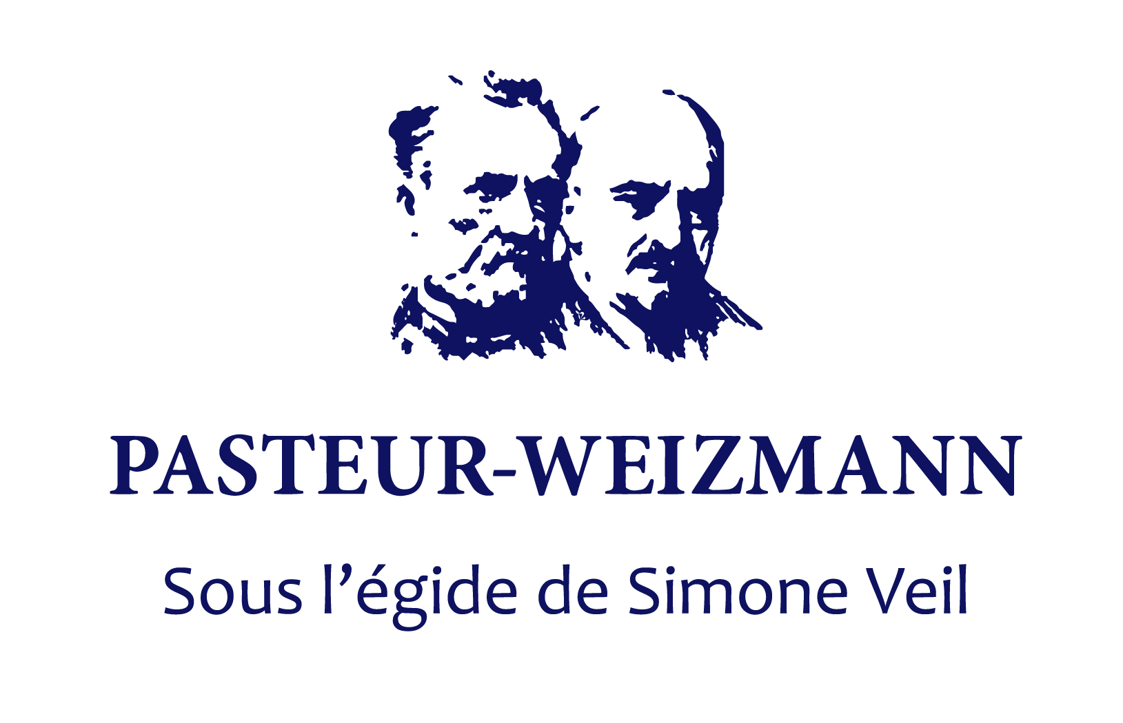

The Pasteur-Weizmann Joint Research Program

Application Template
For the period January 1st, 2021 to December 31st, 2022

Submit the filled template only by email as single pdf document to: yael.karhash@weizmann.ac.il
Name your PDF file as follows: PW 2020 names of both PIs.pdf
Deadline October 18th, 2020, midnight, Israel time

Title of Project:

Principal Investigators

 | Institut Pasteur | Weizmann Institute of Science
Name
Department
email
Telephone

Project Summary (250 words max)
Describe briefly the project’s context, hypothesis, objectives, importance of collaboration and impact in the field.

1. BACKGROUND (2 pages max, font times 11, 1.5 line space. References may go in annex)

  - General Scientific Background

  - Contributions of the collaborating laboratories to the field and unpublished data

- RESEARCH PLAN (5 pages max, font times 11, 1.5 line space. (Only references may go in annex)

  - Objectives:

  - Detailed research plan

  - Mode and importance of the collaboration

  - Expected Results

  - Composition of the research teams

Name / Function  (e.g. PI, PhD student, Postdoc, technician) | Institut Pasteur | Weizmann Institute

  - References (include all authors list and titles)

- BUDGET (one page max)

Up to 70 000 € per year equally split between the two laboratories during 2 years

Proposed assignment of funds:

 | Institut Pasteur | Weizmann Institute
Consumables

Services / Core Facilities

Small equipment

Personnel

Other expenses related with the project

- LIST OF THE PUBLICATIONS OF THE PIs of last 5 years (mark with an asterisk those related with the proposed topic of research. Please number and separate the list of each PI. Indicate full references with all authors and title. Reviews/commentaries should be identified)

