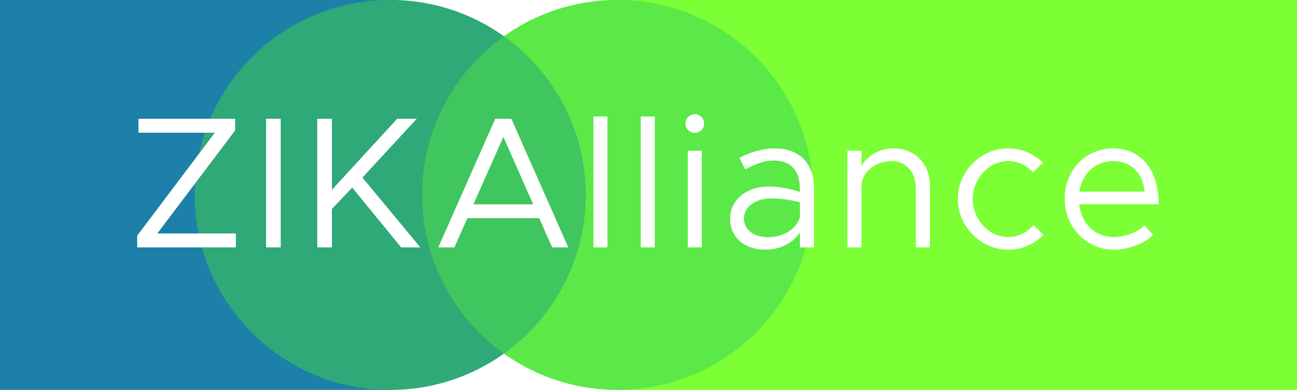
Meeting of WP6 partners within the ZIKALLIANCE consortium
Institut Pasteur (30 – 31 January 2017)

Blandin Stéphanie (Inserm), Boitard Anna (Inserm-transfert), Busquets Nuria (IRTA), Chandre Fabrice (IRD), David Jean-Philippe (CNRS), De Lamballerie Xavier (Inserm), Failloux Anna-Bella (IP, Organiser), Gondard Mathilde (Anses, representing Sara Moutailler), Koenraadt Sander (WU), Kohl Alain (UG), Leggewie Mayke (BNI, representing Esther Schnettler), Lourenço-de-Oliveira Ricardo (IOC), Mariani Flavia (Inserm), Paupy Christophe (IRD), Roenick Olmo (Inserm), Sousa Carla (IHMT), Varjak Marcus (UG), Vazeille Marie (IP), Vega-Rua Anubis (IP Guadeloupe), Veronesi Eva (UZH), Yébakima André (CDM)

